Year: 2  Resources: Story book, pictures of pages from the book , worksheet  (see Rainy Day Zoo resources pack) |  | 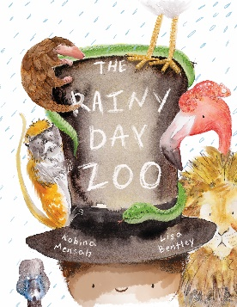  Lesson objective:  Write a new narrative for the Rainy Day Zoo
Book title and Author: The Rainy Day Zoo
Bernard Mensah
Opening activity | Show children the book cover and discuss the illustration.  What can the children tell you about the book? What do they think the story might be about? Who is the main character? What do they think is going to happen?
Lesson input | Read the story The Rainy Day Zoo. Throughout the reading of the story ask the children questions before turning the next page ‘Why do you think the boy was upset?’, ‘What do you think he is going to do?’, ‘What would you do?’. Focus on this question ‘What do you think is going to happen next?’.  Stop reading the story at the end of the page that says ‘And for the grand finale!...’  What do the children think is going to happen next?  Put the children into small groups (around 4 children). Ask them to role play what they think as a group happens next. If they already know the story, can they create a new ending?  Allow practise time and then invite the children to perform their role play.
Independent activities | Children are given the story planning template from the resources pack. They draw illustrations for the next possible three pages of the book to show what happens in their version of The Rainy Day Zoo. Children can use their groups idea for their role play to support them. The children can also use their planning sheet to practise writing some sentences for each of their illustrations and/or jot down some important words or phrases they’d like to use.  When they have finished planning the children can then write their alternative ending using the writing template from the resources pack. Afterwards they can illustrate their ending using one of their story plan illustrations for inspiration.
Plenary | Allow some of the children to share their alternative endings with the class.  Carry on reading the book so that everyone can find out what the real Rainy Day Zoo ending is like. Did anyone do the same? Did anyone prefer one of the alternative endings?
Further teaching points | Children could role play where the little boy goes when he puts on the hat. Does he go to Africa again? Or does he go somewhere different? Outer space? The ocean? A magical land?  From this role play children could plan their own alternative beginning for the story to take the little boy on a new magical adventure!  Children could create their own book from their new plans. A whole sequence of learning incorporating creating illustrations using different media, writing sentences, creating books using simple binding techniques could be used to create their finished products.
