Year: 3  Resources: Story book, pictures of pages from the book , worksheet  (see Rainy Day Zoo resources pack) |  | 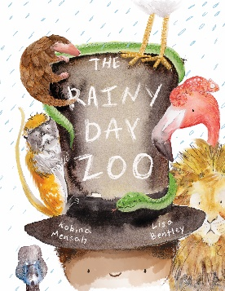  Lesson objective:  Create a new character for The Rainy Day Zoo
Book title and Author: The Rainy Day Zoo
Bernard Mensah
Opening activity | Show children the book cover and discuss the illustration.  What can the children tell you about the book? What do they think the story might be about? What do they think is going to happen?  Who is the main character? What do you think he is like? What do we know about him?
Lesson input | Read the story The Rainy Day Zoo. Ask the children questions about the main character. Where is he from? How old is he? Where does he live? What do you think he likes to do?  Hot seating: Get into character of your new main character. Invite the children to ask you questions about who you are, your feelings, what has happened to you etc. Ask the children if any of them would like a turn and invite the rest of the class to ask them questions.  Divide the children into pairs, taking it in turns to be the interviewer and main character.  Ask the children what they learned about their partners main character.  Modelling writing:  Model creating a character profile for a new main character using the template in the resources pack. Fill in the details and write sentences together about the character. Explain to the children that they are going to create their own character today. It must be different to the boy in the book and it can be any character they like.
Independent activities | Writing:  Explain to the children that they are now going to write about their main character that they pretended to be in the hot seating. Using the writing template, they design their main character and fill in the details as modelled before.  Children write sentences to describe their character in as much detail as possible.
Plenary | Allow some of the children to share their characters with the class. What does everyone think could happen to them in a new story? What if the story was in a different place? What would happen then?
Further teaching points | Children could hot seat again and think about what would happen if their character went to a different place. Does he go to Africa again? Or does he go somewhere different? Outer space? The ocean? A magical land?  From this hot seating children could plan their own alternative narrative for the story to take the little boy on a new magical adventure!  Children could create their own book from their new plans. A whole sequence of learning incorporating creating illustrations using different media, writing sentences, creating books using simple binding techniques could be used to create their finished products.
